

NATIONAL COLLEGE OF IRELAND
OBJECT ORIENTED SOFTWARE ENGINEERING SCHOOL OF COMPUTING

OOSE-2016
Minecraft Creative Mode

Alex Santos dos Reis
Lecturer: Pádraig de Burca

Dublin
December 2016

Alex Santos dos Reis

OOSE-2016
Minecraft Creative Mode

Project developed for Object Oriented Software Engineering subject of the Higher Diploma Certificate in Science in Computing .
Lecturer: Pádraig de Burca

Dublin
December 2016

Minecraft Game Introduction:

Minecraft is a game where you dig (mine) and build (craft) different kinds of 3D blocks within a large world of varying terrains and habitats to explore.
In this world the sun rises and sets as you go about your work, gathering materials and making tools.
There is rain and the occasional lightning storm, and animals that you can tame, farm or use for food. Depending on
which mode you’re playing in, you might also need to fight for your survival against hunger, danger and bad guys.

Creative Mode Challenge:
In Creative mode, players are given an infinite number of blocks to build with, with no health or hunger bar to hamper their building. Creative mode allows players to destroy all blocks instantly (including normally-indestructible blocks such a bedrock and end portal frames, provided they are not holding a sword.

Actors:

• Player (Single Player Mode)

• Multiplayer (Multiple Player Mode)

• Player Controller (keyboard)

• System Administrator

• Bank

Use Case Model:

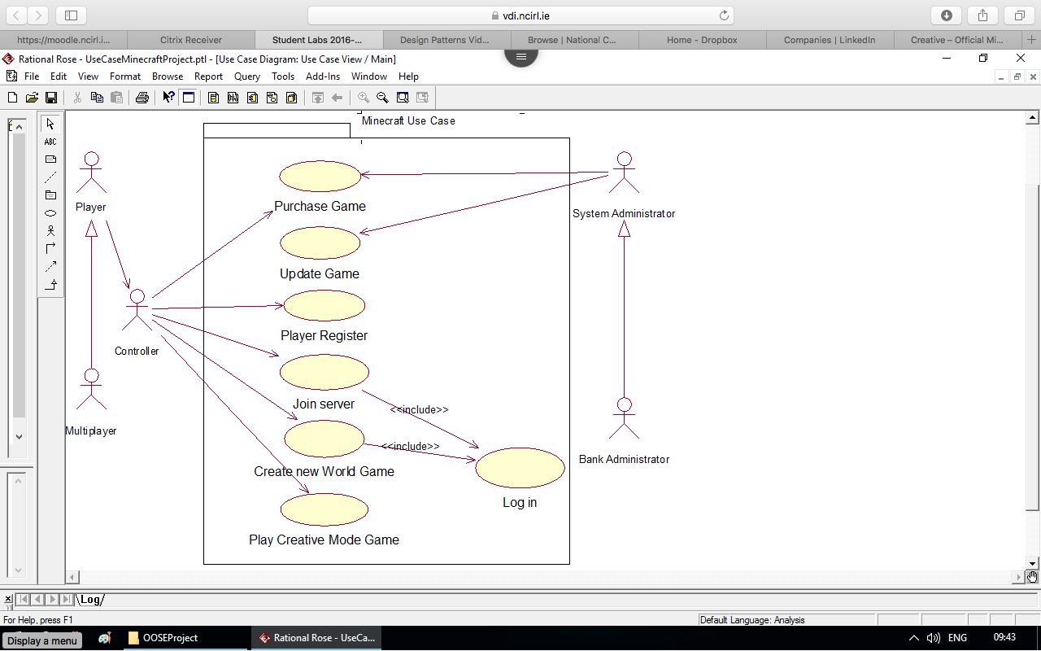

Use Case Description:

Use case describes in details the creative game mode in Minecraft.

Creative Mode

Scope:
Play Creative Game Mode.

Brief description:

This use case allows players to easily create and destroy structures and mechanisms.

Flows of events
Activation:

This use case begins when the player creates a new world creative mode game.

Pre–condition:

Player must create a new World game to play creative mode game.

Basic Flow:

- Players are given an infinitive number of blocks to build with, with no health or hunger bar to hamper their building.

- Player can destroy all blocks instantly (including normally indestructible blocks such as bed rock).

- Player will be given the ability to fly.

- Player gets into a mine cart trolley, while flying will not disable flying when player gets out.

- Players are unable to receive damage in Creative Mode Game.

- Mobs zombies will still spawn but all are neutral towards the player even if the player hits the zombies.

- The end while in creative mode, the ender dragon will still attempt to attack the player, but cannot cause any harm.

- Player goes through the ender dragon in the end.

- Player must go through the process of finding and activating the end portal then the game ends.

Alternate Flow:

3. Player touches the ground when flying disable flying.

5. Player is going too far into the void scenario then player will be killed but player will still have ability to fly.

Special requirement:

- Player must be registered.
- Internet connection

Post – condition:

The game can be manually changed if player want to go back to start or set different difficulty level.

Work Breakdown Structure (WBS)

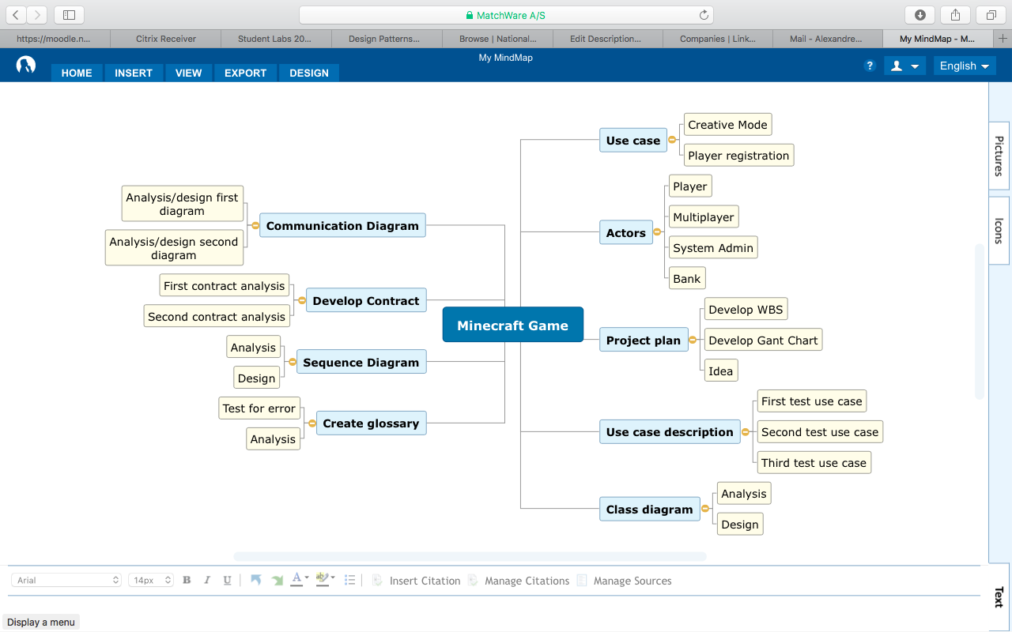

Project Management (Gant Chart):

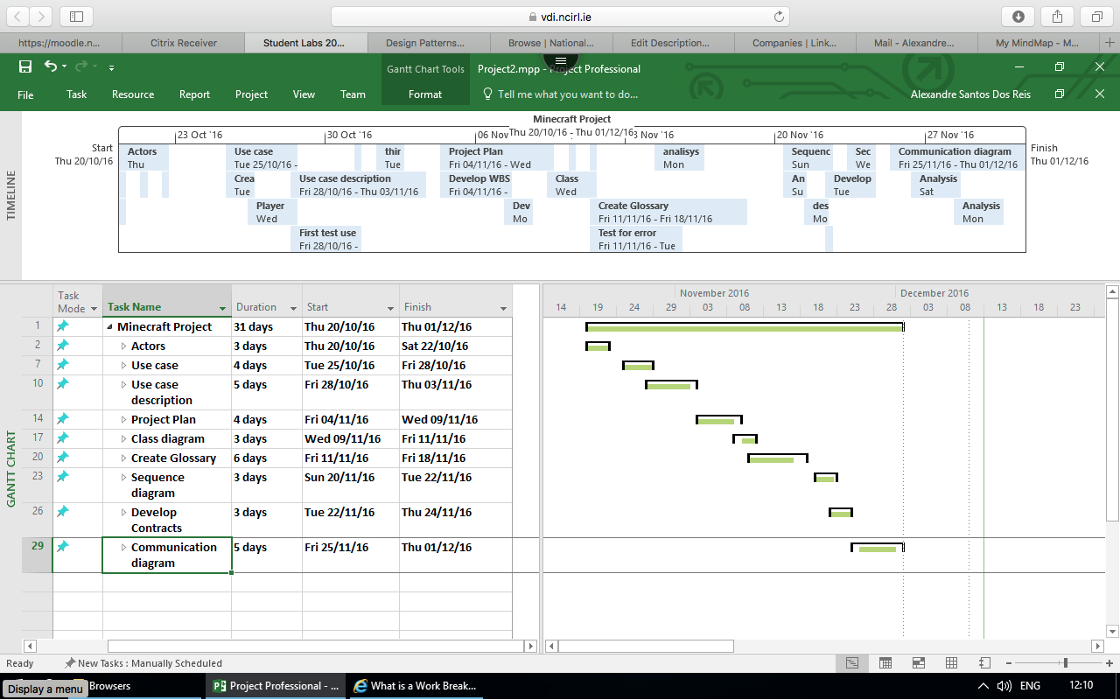

Conceptual Class Diagram of Creative Mode:
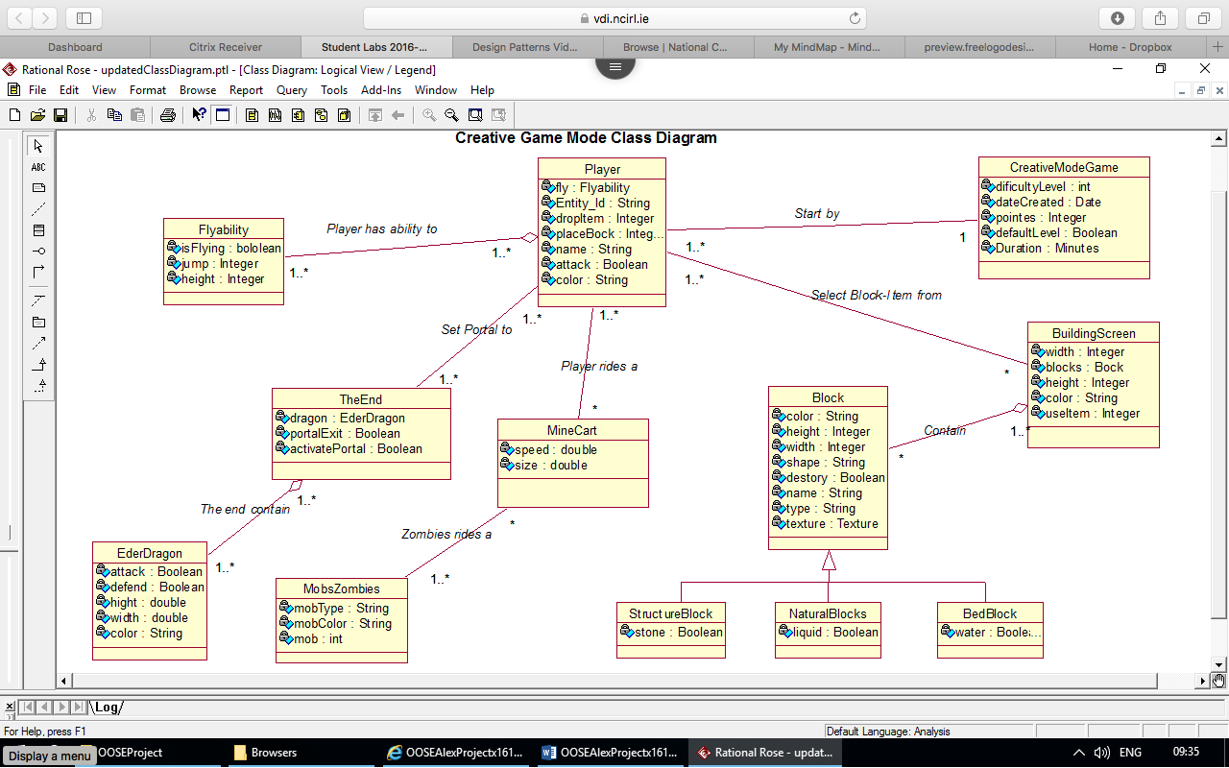

Glossary:

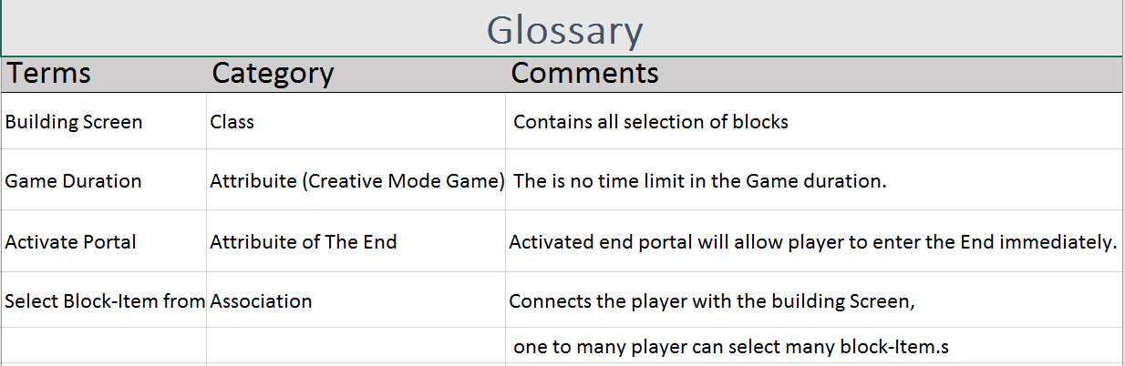

Sequence Diagram:

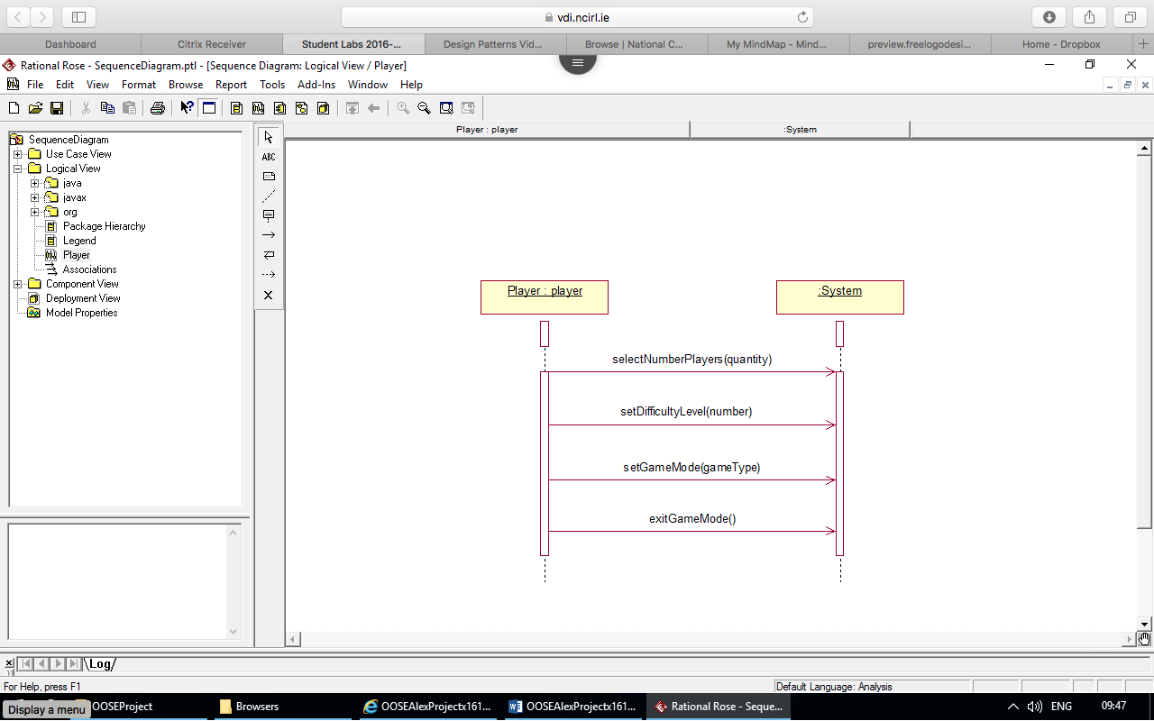

Contract:
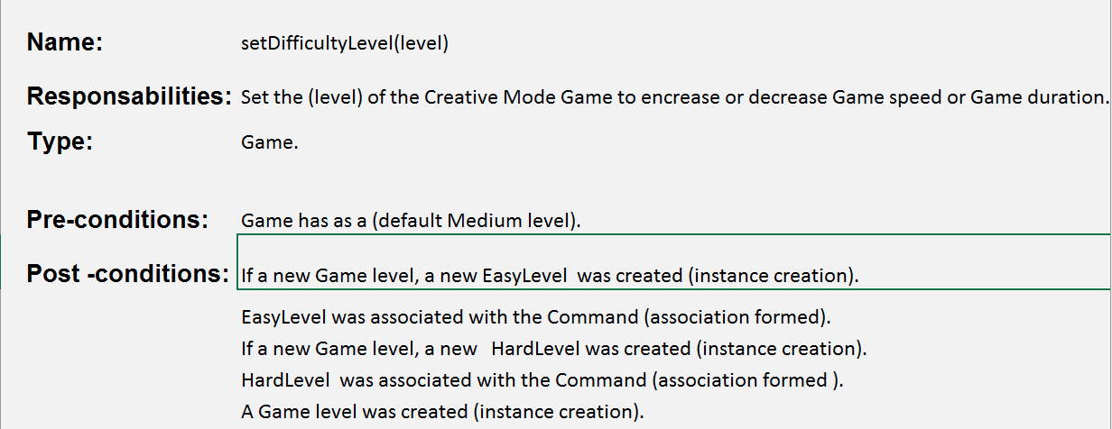

Communication Diagram:
